EGR431 – Control Systems

Project 2: Speed regulation of DC motor

Discussion:
Feedback in a control system is used to control and partially eliminate the effect of disturbance signals. A disturbance signal is an unwanted input signal that affects the system’s output signal. This project studies the effect of open-loop and closed loop speed control of an armature-controlled DC motor.

Part A open-loop control
Figure 1 shows the basic block diagram model of the open-loop control system with Ea(s) representing the reference input and T_{L}(s) representing the load-torque disturbance input.

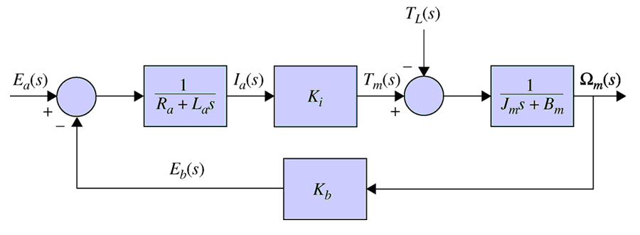
Figure 1: Open-loop speed control system

A1). Please derive the transfer function between the speed output and the disturbance input. 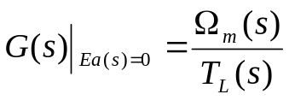
A2). Please develop a Simulink model to simulate the speed output response due to a step disturbance input of 0.1Nm at t=2s with the values provided in table 1. (Use Ea=10 and Ea=20 to get the output responses respectively)

Table 1: DC Motor Parameters
Motor Parameter | Value
Kb | 0.0772 V/rad/s
Ki | 0.067 Nm/A
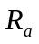 | 0.7454 
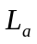 | 4.8 mH
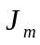 | 6.87x10⁻⁵ Nm/rad/s²
Bm | 0.0003 Nm/(rad/s)

A3). Please estimate the steady state error due to the disturbance.

Part B closed-loop control
Figure 2 shows the closed-loop speed control system with encoder reading as feedback signal.

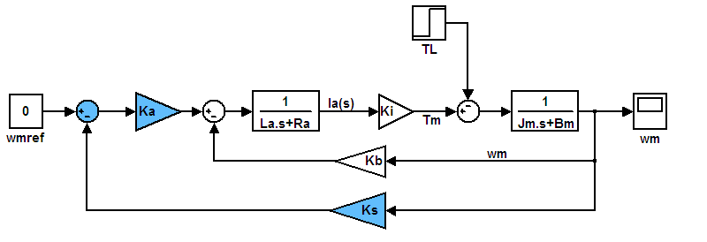
Figure 2: Closed-loop speed control system

B1). Please derive the transfer function between the speed output and the disturbance input. 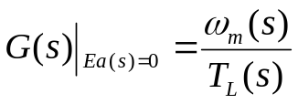
B2). Please develop a Simulink model similar as that in Figure 2 to simulate the speed output response due to a step disturbance input of 0.1Nm at t=2s with the additional controller and sensor values provided in table 2. (Use wmref=0, Ka=5 and wmref =140, Ka=5 to get the output responses respectively.)

Table 2: Controller and sensor Parameters
Motor Parameter | Value
Ks | 1
Ka | 5

B3). Please estimate the steady state error due to the disturbance.
B4). Please try different values with Ka (for example 100 or 40). (Use wmref=140, Ka=40 and wmref =140, Ka=100 to get the output responses respectively.)
What’s your finding?

Part C comparison and conclusion
Please compare the result from A3 with that from B3 and interpret your findings. (hint: please read the discussion part)

